MEMORANDUM OF AGREEMENT

BETWEEN: RICHMOND CABS LTD.
{hereinafter referred to as the "Employer") PARTY OF THE FIRST PART

AND:

MoveUP, Local 378 of the Canadian Office and Professional Employees Union

{hereinafter referred to as the "Union") PARTY OF THE SECOND PART
WHEREAS:

- The Parties are bound to a Collective Agreement effective from January 1, 2022 through March 31, 2024 (the "Collective Agreement'').

- The Parties have engaged in collective bargaining to reach an agreement to renew the Collective Agreement.

THEREFORE:

  - The Parties agree that the Collective Agreement is renewed for a term of two (2) years and three (3) months from January 1, 2022 to March 31, 2024 with the changes set out in the Memorandum of Agreement subject to the following conditions.

  - The Parties agree that this Memorandum of Agreement is subject to ratification by the Parties' respective principals.

  - The Parties agree to recommend this Memorandum of Agreement, without reservation, to their respective principals.

  - The changes to the Collective Agreement contained in this Memorandum of Agreement will be effective from January 1, 2022 unless specifically stated otherwise.

  - The parties agree that upon ratirfication, the one active member, Oldrich Klos, will be paid by the Employer a two thousand dollar ($2,000) signing bonus in lieu of retroactive pay.

  - The parties agree that the one active member, Oldrich Klos, will receive a 9.78% pay increase to $20.95 per hour effective May 1, 2023.

  - The parties agree to strike Letter of Understanding #3.

  - All items not addressed herein will be considered withdrawn on a without prejudice basis.

  - Any amendment to this Memorandum of Agreement must be confirmed in writing by both Parties.

  - The Parties agree that this Memorandum of Agreement is, to this date, the entire agreement between the Parties with respect to collective bargaining for the renewal of a Collective Agreement.

  - If this Memorandum is ratified, the Union agrees to provide the Employer with a draft copy of the resultant Collective Agreement both in "hard-copy" and digital form within thirty (30) calendar days of the date of completion of the ratification vote and the Employer shall thereafter have fifteen (15) calendar days within which to respond to the draft Collective Agreement provided by the Union. The Parties agree the objective will be to have a finalized Collective Agreement within sixty (60) calendar days of the date of completion of the ratification vote.

Richmond Taxi Co. Ltd.
2440 Shell Rd, Richmond BC
Signed at V6X 2P1 Canada B.C. this 17 day of MAY , 2023.

FOR THE EMPLOYER
General Manager
Richmond Cabs Ltd/Coral Cabs Ltd 2440 Shell Road, Richmond BC
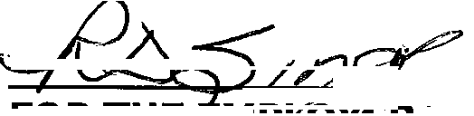
v6X 2P1

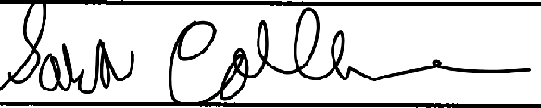

FOR THE UNION

2

APPENDIX "A"

3

Union
Number | Affected Article/MOU | Date: | Time:
UP 01 |  | Housekeeping

Amend "subarticle" to "article" Amend "subclause" to "article" Amend "clause" to "article"

E&OE

Signed off this __17___ day of __May___ 2023.

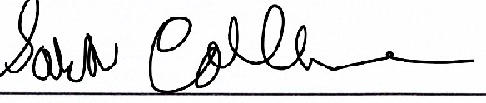
For the Union For the Employer General Manager
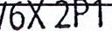
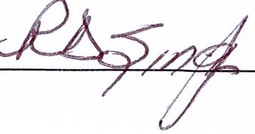
Richmond Cabs Ltd/Coral Cabs Ltd 2440 ShellRoad, Richmond BC

RICHMOND CABS

PROPOSALS 2022
Employer Proposals

Union
Number | Affected Article/MOU | Date: February 21, 2023 | Time:
UP 02 | Article 6.01 a | Amend/Housekeeping

ARTICLE 6 - HOURS OF WORK, OVERTIME AND SHIFT PREMIUM
  - Shift Schedules
Each full-time regular and part-time regular employee will have an established shift falling within the hours set out as follows:
    - Office Clerk/Call Taker/Senior Clerk
      - Full-time regular
The regular work week shall consist of forty ( 40) thirty fiye (35) hours, jnel(cluding the daily paid one (1) hour lunch period, seYefr-eight (!P) coRsecutive hours per day, over five (5) consecutive days, Monday to Friday inclusive. The daily shift shall be within the hours of 28:00
a.m. to 5:00 p.m.

-[ Formatted: Left, Line spacing: single

EMPLOYER AMEND : 21/2/2023

E&OE

Signed off this __17___ day of __May___ 2023.

For the Union For the Employer

Union
Number | Affected Article/MOU | Date: February 21, 2023 | Time:
UP 03 | Article 7.01 | Amend

ARTICLE 7- PAID HOLIDAYS

7.01 Paid Holidays Observed
The Employer agrees to provide all full-time employees with the following paid holidays:

New Year's Day | Family Day | Good Friday
Easter Monday | Victoria Day | Canada Day
BC Day | Labour Day | Thanksgiving Day
National Oat For Truth & | Remembrance Day | Christmas Day
Reconciliation
Boxinq Day

and any other day that is declared a legal holiday by the federal, provincial and/or civic government(s). The Employer further agrees that should one of the above paid holidays fall on an employee's regularly scheduled day off, the employee shall receive an additional day's pay in lieu.

E&OE

Signed off this_____17 day of ____May 2023.

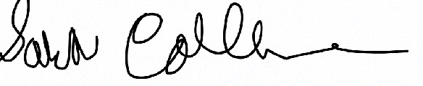
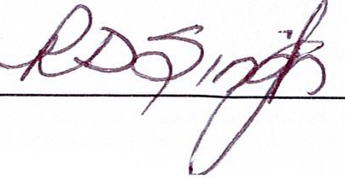
For the Union For the Employer

Union
Number | Affected Article/MOU | Date: May 11, 2023 | Time: 4:00pm
UP 04 | Article 10.01 | Amend Version 2

ARTICLE 10-SICK LEAVE AND WELFARE PLANS

10.01 Sick Leave

On January 1 of each year, all employees, including casual employees, shall be granted five (5) paid sick leave days. Such entitlement replicates the provisions of the BC Employment Standards Act and will be amended in accordance with the legislated changes to that Act, during the term of this Agreement.

Any new employees, including casual employees, shall be granted five (5) sick leave days after ninety (90) calendar days. Such entitlement replicates the provisions of the BC Employment Standards Act and will be amended in accordance with the legislated changes to that Act, during the term of this Agreement.

In addition to the above, the Employer will allow each regular employee who normally works thirty-two (32) hours or more per week an additional one (1) working day per month sick leave with full pay with a maximum credit of twelve (12) days per year. These 7 additional sick days will accrue at one (1) working day per month from June to December each year. The Employer will allow each part-time regular employee one-half(½) working day per month sick leave with full pay with a maximum credit of six (6) days per year. Such sick leave may be accumulated from month to month and year to year up to a maximum of twelve (12) actual working days. The Employer may request a sufficient doctor's certificate for single absences due to illness or injury lasting for more than three
(3) days. The Employer shall cover all costs of doctor's certificate should the Employer request one. Absence due to illness or injury in excess of an employee's paid sick leave entitlement shall be unpaid unless other categories of leave explicitly apply.

Signed off this __17____ day of __May____ 2023.

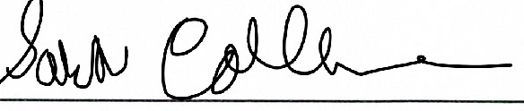
For the Union For the Employer
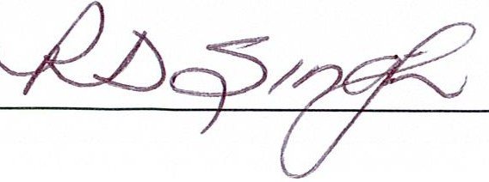

Union
Number | Affected Article/ MOU | Date: February 21, 2023 | Time:
UP 06 | Article 13.03 | Amend

ARTICLE 13 - LAY-OFF, RECALL AND SEVERANCE

13.03 Eligibility for Recall List

Any full-time regular or part-time regular employee with six (6) months or more of service who is laid-off due to lack of work or redundancy, shall be placed on the recall list for a period of one (1) year. The recall period may be extended due to special circumstances (e.g., pandemic), which is mutually agreed between the parties.

E&OE

Signed off this __17___ day of __May___ 2023.
For the Union For the employer
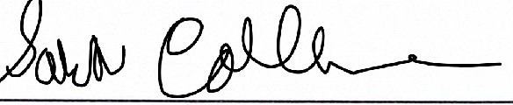

Union
Number | Affected Article/MOU | Date: May 2, 2023 | Time:
UP 09 | Article 19 | Amend

ARTICLE 19-ALTERNATE GRIEVANCE PROCEDURE

Where a difference arises between the Parties relating to the dismissal, discipline or suspension of an employee, or to the interpretation, application, operation or alleged violation of this Agreement, including any question as to whether a matter is arbitrable, during the term of the Collective Agreement Mr. Vince Ready Mr. Ken Saunders, or a substitute mutually agreed to by the Parties, shall at the request of either Party
- investigate the difference,
- define the issue in the difference; and
- make written recommendations to resolve the difference within five (5) days of the date of receipt of the request; and, for those five (5) days from that date, time does not run in respect of the grievance procedure.

E&OE
Signed off this __17__ day of __May__ 2023.

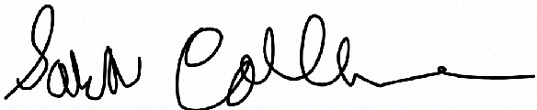
For the Union For the Employer

Union
Number | Affected Article/MOU | Date: February 21, 2023 | Time:
UP 11 | Article 21.03 | Amend

ARTICLE 21- Duration

21.03 Agreement to Continue in Force

@l Both Parties shall comply fully with the terms of this Agreement during the period of collective bargaining, and until a new or revised Agreement is signed by the Parties, without prejudicing the position of the new or revised Agreement in making any matter retroactive in such revised Agreement. Notwithstanding the foregoing, the Parties shall have the right to affect a legal strike, or a legal lockout, as the case may be.

{Q)_ Alter the expiry date of this Agreement and until a revised agreement is signed, this Agreement and all its provisions shall remain in full force and effect without prejudicing the position of the revised agreement in making any matter retroactive in such revised agreement.

E&OE
Signed off this __17__ Day of __May___ 2023.

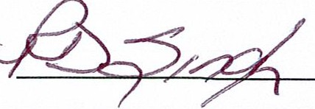
For the Union For the Employer

