MoveUP Monthly Ingredient Recipe – October – Instant Pot
[Click here to add ingredients.]  [Press the down arrow key to move to a new line.]  [To delete tip text (such as this) just click it and type.] |  | 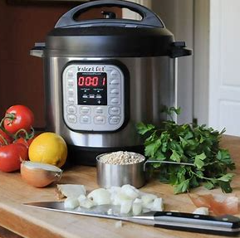  [Date]  (Name) (Employer)

[Recipe Name]
[Click here to add instructions.]

Add Photo (Optional):

